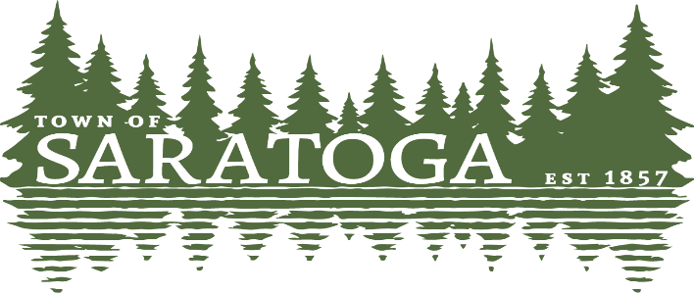
WOOD COUNTY, WISCONSIN
_____________________________________________________________________________________________

SPARKS Committee Meeting Agenda
Monday, September 26, 2022 @ 6:00pm
Meeting will take place at the Town’s administrative building.

AGENDA
1. Call to order and declaration of quorum

2. Public comment (rules may apply)

3. Approve minutes for August 15, 2022 meeting

4. Outdoor Recreation Plan
a. goals and objectives

5. Information and comments from committee members

6. Prepare for October 5, 2022 CEED Grant meeting

7. Update on Schalow’s site plan
a. bids
b. quotes
c. recommendations
d. end of year construction activities

8. Knowles-Nelson Grant

9. Historic Point Basse

10. Set our next meeting date and discuss items for next meeting agenda

10. Adjourn

Paulette Weinfurter Clerk
Posted 9-23-22

