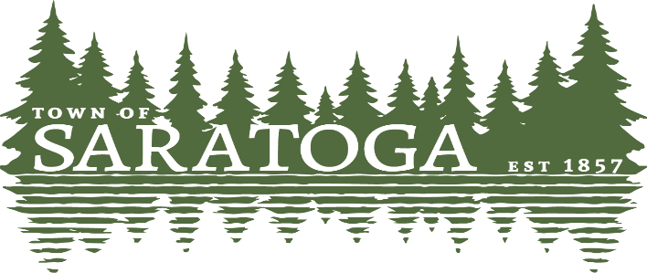
WOOD COUNTY, WISCONSIN
_____________________________________________________________________________________________

August 17,2022
The Saratoga Town Board met at 4:00pm in the Town Board Room. Chairman Carrell called the meeting to order. All members were present. The meeting was officially noticed on August 12, 2022.
Leichtnam made a motion to go into closed session under Wisconsin Statutes §19.85 (1) (e); Deliberating or negotiating the purchasing of public properties, the investing of public funds, or conduction other specified public business, whenever competitive or bargaining reasons require a closed session. McDonald seconded the motion. Roll call was taken Carrell-aye, Kretschmer-aye, McDonald-aye, Leichtnam-aye, Wilcox-aye. Motion passed unanimously.
Leichtnam made a motion to adjourn the closed session and go into open session. Wilcox seconded the motion. Motion passed unanimously.
McDonald made a motion to keep the Town Funds currently secured with Nekoosa Port Edwards State Bank in that institution. Kretschmer seconded the motion. Motion passed unanimously.
McDonald made a motion to adjourn. Leichtnam seconded the motion. Motion passed unanimously. Minutes by Chairman Carrell

